

ASSET VERIFICATION AND RECORDING TOOL KIT


Plot 31, Bukoto Street
P.O Box 7657, Kampala, Uganda
+256 (0) 39 2000216/0772525235
email: cpa@cpa.ug

www.cpa.com

August to September 2026

SCHOOL VERIFICATION CHECKLIST

SCHOOL INTERVIEW/DISCUSSION GUIDE

Name of school: BUDDE SEED SECONDARY

1a | Does the Facility have a record of all assets provided under UgIFT?  (Obtain a record and verify if it has the costs and numbers supplied | Not yet in possession
1b | If Not ask how many were supplied and when.

2 | How does this facility Maintain (repair/service/replace) the assets provided under Ugift

3 | Does the facility take regular record about functionality/ or breakdown of the assets provided?  Nonfunctional/ working, and reasons for non-functionality.

4 | How has the UgIFT support helped in service delivery in the area, any issues, challenges and any recommendations for better program implementation.

PROCEED TO VERIFICATION AFTER THIS DISCUSSION

SCHOOL FURNITURE
(School Desks, Office chairs, Laboratory stools, Book shelves)

Name of LG: BUTAMBALA LOCAL GOVERNMENT
Name of SCHOOL: BUDDE SEED SECONDARY SCHOOL

Equipment/ Item | Department | Asset Number | Item  Description | Life in Months | Tag Number (engrave no.) | Date of Pur | Date Placed in Service | Recoverable cost | Cost | Acc Dep Cost | Net Book Value | Ytd Deprn | Equipment status | Remarks
CLASSROOM |  |  | CLASSROOM  3-SEATER DESK |  | UgIFT/BUDDE SEED S.S CLSRM DESK OO1-120 |  |  |  |  |  |  |  | Still in a good condition and fit for use
 |  |  | TEACHERS  TABLES |  | QTY 6 |  |  |  |  |  |  |  |  | Teachers tables in classrooms aren’t engraved
SCIENCE LAB |  |  | LAB STOOL |  | UgIFT/BUDDE SEED S.S STOOL 001-096

ICT ITEMS TO VERIFY
(Desktop Computer, Server Processor, Network Switch 24 Port, Multipurpose Printer, UPS, Projector, Air Conditioners, Server, CCTV Camera)

Name of LG: BUTAMBALA LOCAL GOVERNMENT: Name of SCHOOL: BUDDE SEED SECONDARY SCHOOL

Equipment/ Item | Department | Asset Number | Item  Description | Life in Months | Tag Number (engrave no.) | Date of Purchase | Date Placed in Service | Recoverable cost | Cost | Acc Dep Cost | Net Book Value | Ytd Deprn | Equipment status | Remarks
COMPUTER-DESKTOP | EDUCATION |  | BX64CF3 CORE i7 |  | BDSS/CMP/001 | 3/01/2022 | 3/01/2022 |  | 4,000,000/= |  |  |  | GOOD
COMPUTER-DESKTOP | EDUCATION |  | B6HKFF3 |  | BDSS/CMP/002 | 3/01/2022 | 3/01/2022 |  | 4,000,000/= |  |  |  | GOOD
COMPUTER-DESKTOP | EDDUCATION |  | DWGKFF3 |  | BDSS/CMP/003 | 3/01/2022 | 3/01/2022 |  | 4,000,000/= |  |  |  | GOOD
COMPUTER-DESKTOP | EDUCATION |  | 25HKFF3 |  | BDSS/CMP/004 | 3/01/2022 | 3/01/2022 |  | 4,000,000/= |  |  |  | FAULTY
COMPUTER-DESKTOP | EDUCATION |  | 4LHKFF3 |  | BDSS/CMP/005 | 3/01/2022 | 3/01/2022 |  | 4,000,000/= |  |  |  | GOOD
COMPUTER-DESKTOP | EDUCATION |  | FYGKFF3 |  | BDSS/CMP/006 | 3/01/2022 | 3/01/2022 |  | 4,000,000/= |  |  |  | GOOD
COMPUTER-DESKTOP | EDUCATION |  | FDMKFF3 |  | BDSS/CMP/007 | 3/01/2022 | 3/01/2022 |  | 4,000,000/= |  |  |  | FAULTY
COMPUTER-DESKTOP | EDUCATION |  | FW64CF3 |  | BDSS/CMP/008 | 3/01/2022 | 3/01/2022 |  | 4,000,000/= |  |  |  | GOOD
COMPUTER-DESKTOP | EDUCATION |  | BYGKFF3 |  | BDSS/CMP/009 | 3/01/2022 | 3/01/2022 |  | 4,000,000/= |  |  |  | FAULTY
COMPUTER-DESKTOP | EDUCATION |  | GTGKFF3 |  | BDSS/CMP/010 | 3/01/2022 | 3/01/2022 |  | 4,000,000/= |  |  |  | GOOD
COMPUTER-DESKTOP | EDUCATION |  | J5HKFF3 |  | BDSS/CMP/011 | 3/01/2022 | 3/01/2022 |  | 4,000,000/= |  |  |  | GOOD
COMPUTER-DESKTOP | EDUCATION |  | INHKFF3 |  | BDSS/CMP/012 | 3/01/2022 | 3/01/2022 |  | 4,000,000/= |  |  |  | FAULTY
COMPUTER-DESKTOP | EDUCATION |  | D6MKFF3 |  | BDSS/CMP/013 | 3/01/2022 | 3/01/2022 |  | 4,000,000/= |  |  |  | GOOD
COMPUTER-DESKTOP | EDUCATION |  | 46MKFF3 |  | BDSS/CMP/014 | 3/01/2022 | 3/01/2022 |  | 4,000,000/= |  |  |  | GOOD
COMPUTER-DESKTOP | EDUCATION |  | 8GHKFF3 |  | BDSS/CMP/015 | 3/01/2022 | 3/01/2022 |  | 4,000,000/= |  |  |  | GOOD
COMPUTER-DESKTOP | EDUCATION |  | 7FMKFF3 |  | BDSS/CMP/016 | 3/01/2022 | 3/01/2022 |  | 4,000,000/= |  |  |  | GOOD
COMPUTER-DESKTOP | EDUCATION |  | 8T64CF3 |  | BDSS/CMP/017 | 3/01/2022 | 3/01/2022 |  | 4,000,000/= |  |  |  | GOOD
COMPUTER-DESKTOP | EDUCATION |  | IJHKFF3 |  | BDSS/CMP/018 | 3/01/2022 | 3/01/2022 |  | 4,000,000/= |  |  |  | GOOD
COMPUTER-DESKTOP | EDUCATION |  | BTHKFF3 |  | BDSS/CMP/019 | 3/01/2022 | 3/01/2022 |  | 4,000,000/= |  |  |  | GOOD
COMPUTER-DESKTOP | EDUCATION |  | 36MKFF3 |  | BDSS/CMP/020 | 3/01/2022 | 3/01/2022 |  | 4,000,000/= |  |  |  | GOOD
COMPUTER-DESKTOP | EDUCATION |  | 68MKFF3 |  | BDSS/CMP/021 | 3/01/2022 | 3/01/2022 |  | 4,000,000/= |  |  |  | GOOD
COMPUTER-DESKTOP | EDUCATION |  | 8GMKFF3 |  | BDSS/CMP/022 | 3/01/2022 | 3/01/2022 |  | 4,000,000/= |  |  |  | GOOD
COMPUTER-DESKTOP | EDUCATION |  | JNHKFF3 |  | BDSS/CMP/023 | 3/01/2022 | 3/01/2022 |  | 4,000,000/= |  |  |  | GOOD
COMPUTER-DESKTOP | EDUCATION |  | C5MKFF3 |  | BDSS/CMP/024 | 3/01/2022 | 3/01/2022 |  | 4,000,000/= |  |  |  | FAULTY
COMPUTER-DESKTOP | EDUCATION |  | BFHKFF3 |  | BDSS/CMP/025 | 3/01/2022 | 3/01/2022 |  | 4,000,000/= |  |  |  | GOOD
COMPUTER-DESKTOP | EDUCATION |  | C1HKFF3 |  | BDSS/CMP/026 | 3/01/2022 | 3/01/2022 |  | 4,000,000/= |  |  |  | GOOD
COMPUTER-DESKTOP | EDUCATION |  | 58MKFF3 |  | BDSS/CMP/027 | 3/01/2022 | 3/01/2022 |  | 4,000,000/= |  |  |  | GOOD
COMPUTER-DESKTOP | EDUCATION |  | 9BHKFF3 |  | BDSS/CMP/028 | 3/01/2022 | 3/01/2022 |  | 4,000,000/= |  |  |  | GOOD
COMPUTER-DESKTOP | EDUCATION |  | BV64CF3 |  | BDSS/CMP/029 | 3/01/2022 | 3/01/2022 |  | 4,000,000/= |  |  |  | GOOD
PROJECTOR | EDUCATION |  | X89T1400447 |  | BDSS/Prj/SS/001 | 3/01/2022 | 3/01/2022 |  | 2,310,000/= |  |  |  | FAIR
PRINITER | EDUCATION |  |  |  | BDSS/Prt/SS/001 | 3/01/2022 | 3/01/2022 |  | 2,000,000/=
CCTV-CAMERA | EDUCATION |  |  |  | BDSS/cct/SS/001 | 3/01/2022 | 3/01/2022 |  | 2,059,750/=
SERVER PROCESSOR | EDUCATION |  |  |  | BDSS/srv/SS/001 | 3/01/2022 | 3/01/2022 |  | 3,700,000/=
AIR CONDITIONER | EDUCATION |  | 0000624 |  | BDSS/ar/SS/001 | 3/01/2022 | 3/01/2022 |  | 6,730,000/= |  |  |  | FAIR
UPS | EDUCATION |  | 2107AB0163
UPS | EDUCATION |  | 2107ABO688
UPS | EDUCATION
UPS | EDUCATION |  | 2107ABO529
UPS | EDUCATION |  | 2107ABO530
UPS | EDUCATION
UPS | EDUCATION |  | 2107AB0531
UPS | EDUCATION |  | 2107AB0784
UPS | EDUCATION
UPS | EDUCATION
UPS | EDUCATION
UPS | EDUCATION
UPS | EDUCATION
UPS | EDUCATION
UPS | EDUCATION
UPS | EDUCATION
UPS | EDUCATION
UPS | EDUCATION
UPS | EDUCATION
UPS | EDUCATION
UPS | EDUCATION
UPS | EDUCATION
UPS | EDUCATION
UPS | EDUCATION
UPS | EDUCATION
UPS | EDUCATION
BUILDINGS TO VERIFY
(Non- Residential and Residential, Kitchen, Toilets/Pit latrine Water tanks, Fences etc.)

Name of LG; BUTAMBALA LOCAL GOVERNMENT Name of SCHOOL: BUDDE SEED SECONDARY SCHOOL

Equipment/ Item | Department | Asset Number | Item  Description | Life in Months | Tag Number (engrave no.) | Date of Purchase | Date Placed in Service | Recoverable cost | Cost | Acc Dep Cost | Net Book Value | Ytd Deprn | Equipment status | Remarks
RESIDENTIAL | EDUCATION |  | ADMINISTRATION  BLOCK |  |  |  | 1/10/2022 |  |  |  |  |  | Worn off paint | Number of floors;1  Number of rooms;1
RESIDENTIAL | EDUCATION |  | MULTIPURPOSE HALL |  |  |  | 1/10/2022 |  |  |  |  |  | FUNCTIONAL
RESIDENTIAL | EDUCATION |  | ICT/LIBRARY |  |  |  |  |  |  |  |  |  | FUNCTIONAL
RESIDENTIAL | EDUCATION |  | SCIENCE LAB BLOCK |  |  |  |  |  |  |  |  |  | FULLY FURNISHED
RESIDENTIAL | EDUCATION |  | CLASSROOM BLOCKS  QTY;3 |  |  |  |  |  |  |  |  |  | FULLY FURNISHED
RESIDENTIAL | EDUCATION |  | 03 STAFF QUARTERS |  |  |  |  |  |  |  |  |  | FULLY FURNISHED
RESIDENTIAL | EDUCATION

PICTORIAL EVIDENCE
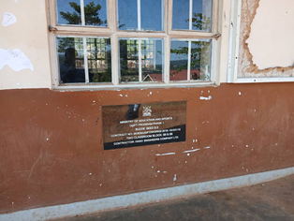 | 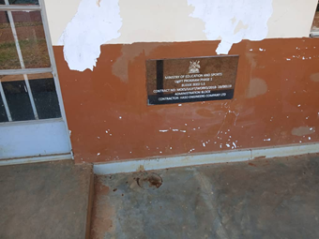 | 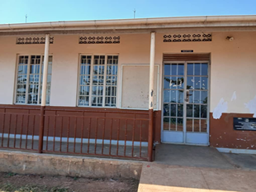
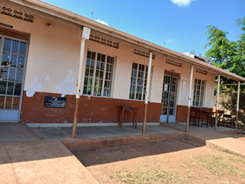 | 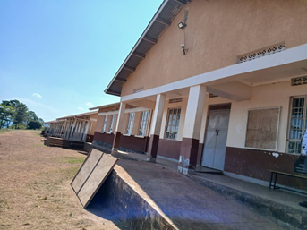 | 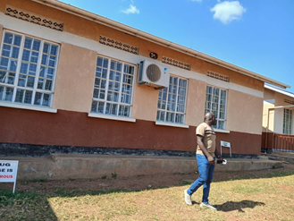
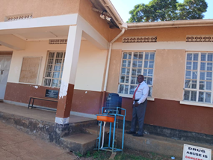 | 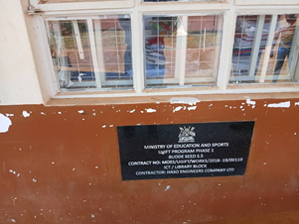 | 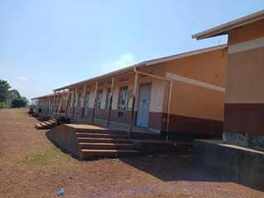
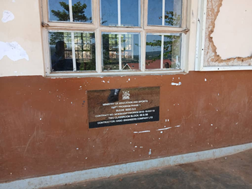 | 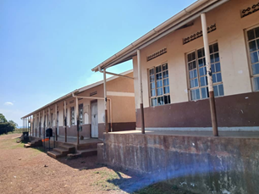 | 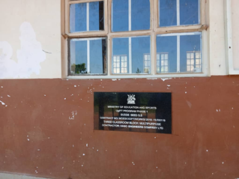
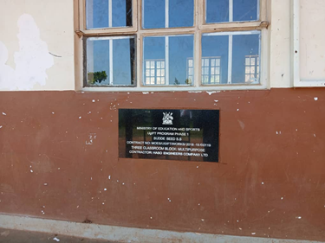 | 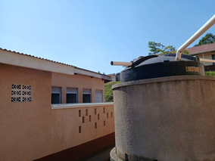 | 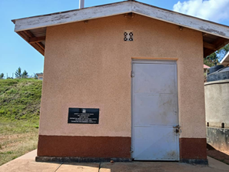
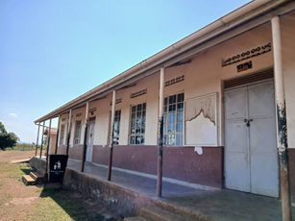 | 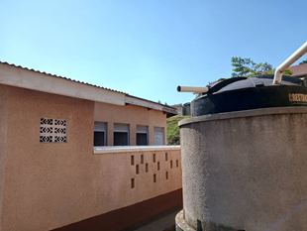 | 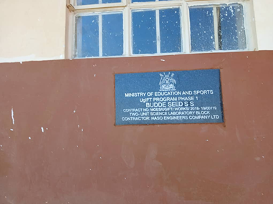
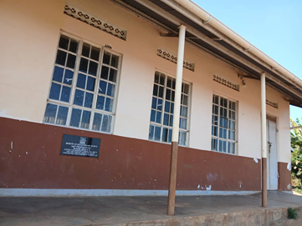 | 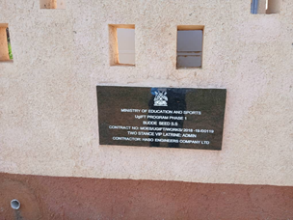 | 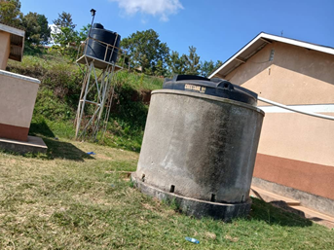
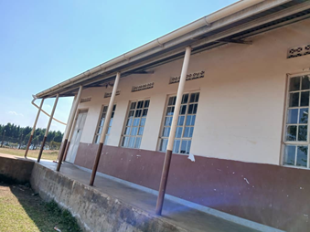 | 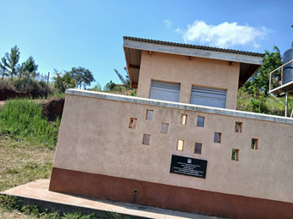 | 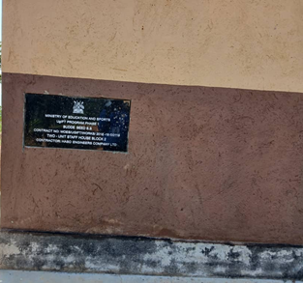
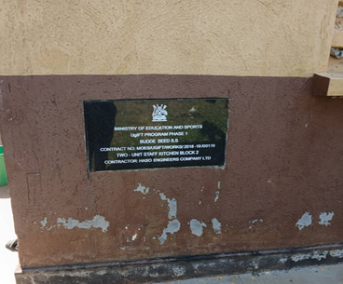 | 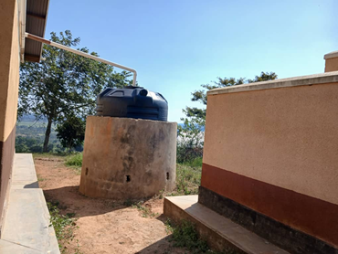 | 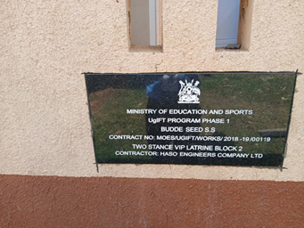
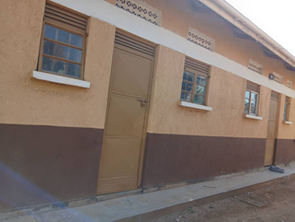 | 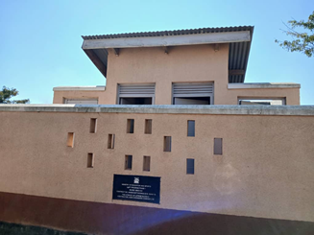 | 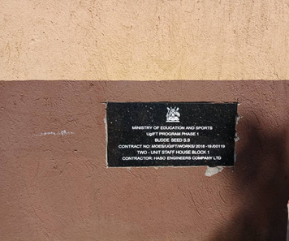
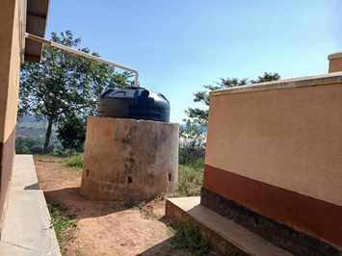 | 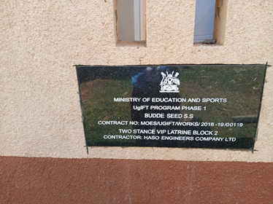 | 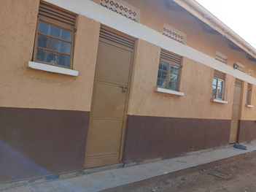
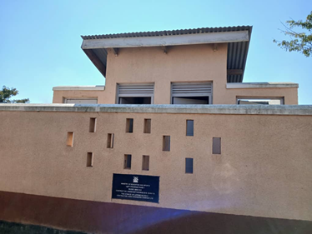 | 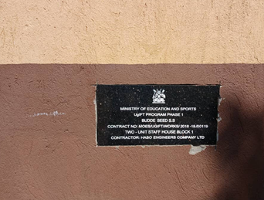 | 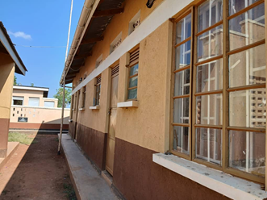
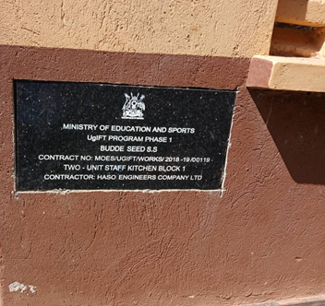 | 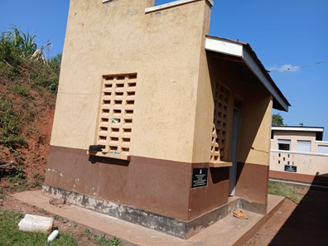 | 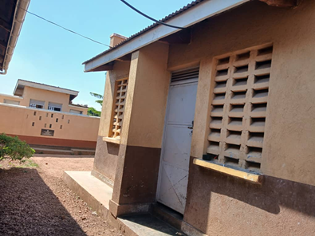
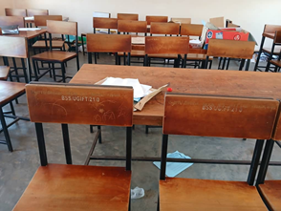 | 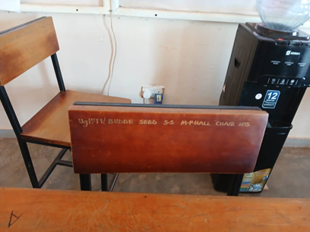 | 